Topic 6.4: Sudoku Puzzle Solver
Question
Write a program to solve a Sudoku puzzle by filling the empty cells.
A Sudoku solution must satisfy all of the following rules:
- Each of the digits 1–9 must occur exactly once in each row.
- Each of the digits 1–9 must occur exactly once in each column.
- Each of the digits 1–9 must occur exactly once in each of the 9 sub-boxes of the grid.
The '.' character indicates empty cells.
Aim
To implement a backtracking algorithm to solve a partially filled Sudoku board, ensuring all Sudoku rules are satisfied.
Algorithm
- Start with the given Sudoku board.
- Locate the first empty cell.
- Try placing digits 1–9 in that cell.
- For each placement, check validity:
  - Not already in the same row.
  - Not already in the same column.
  - Not already in the corresponding 3×3 sub-box.
- If valid, place the number and continue recursively to solve the next empty cell.
- If no number is valid, backtrack and try a new value in the previous cell.
- Continue until all cells are filled, producing the solution.
Output
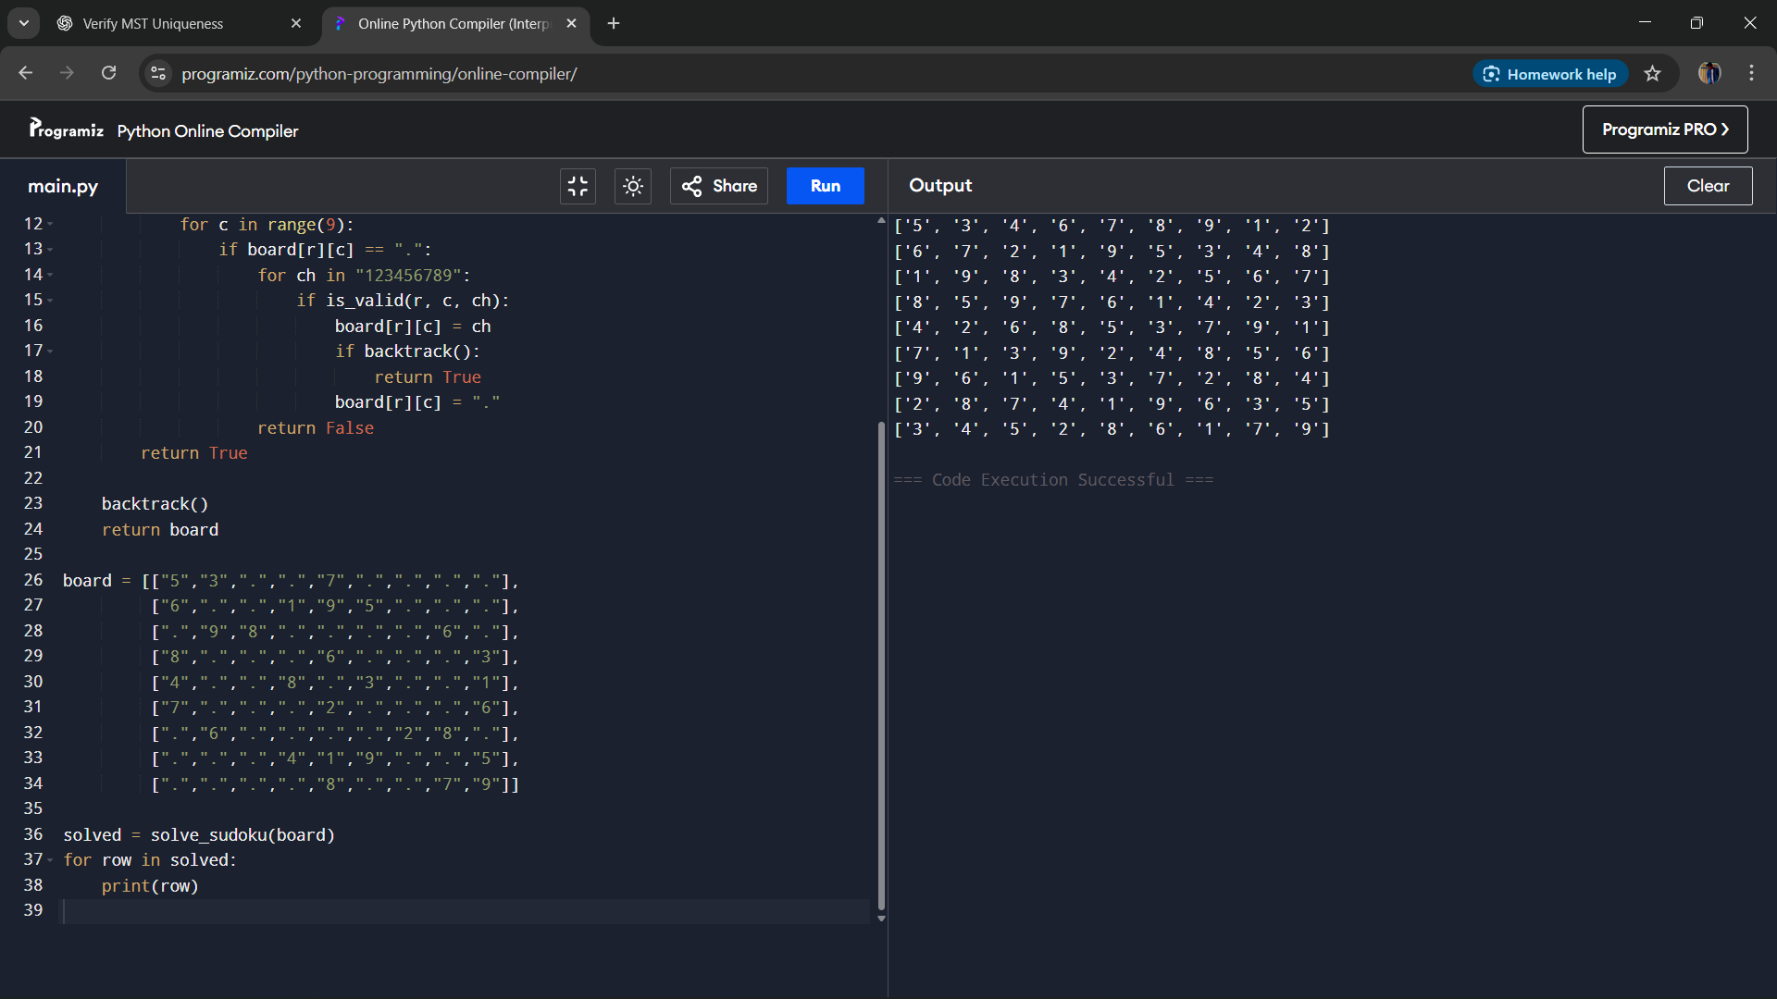
Result
The Sudoku puzzle was solved successfully using backtracking and constraint checking.
Performance Analysis
- Time Complexity: O(9^n) in the worst case, where n is the number of empty cells.
- Space Complexity: O(1) for the fixed-size board and O(n) for the recursion stack.

